**Hygieia DashBoard Configuration**

**Team Dashboard:**

* Click on create new dashboard

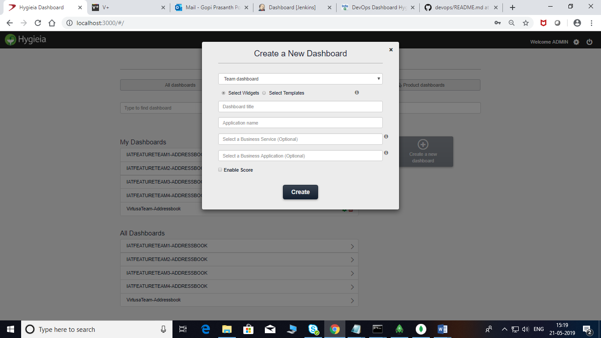

* Select widgets or select a template from dropdown
* Fill all the required fields and click on create

**After that open the created Dashboard from My Dashboards**

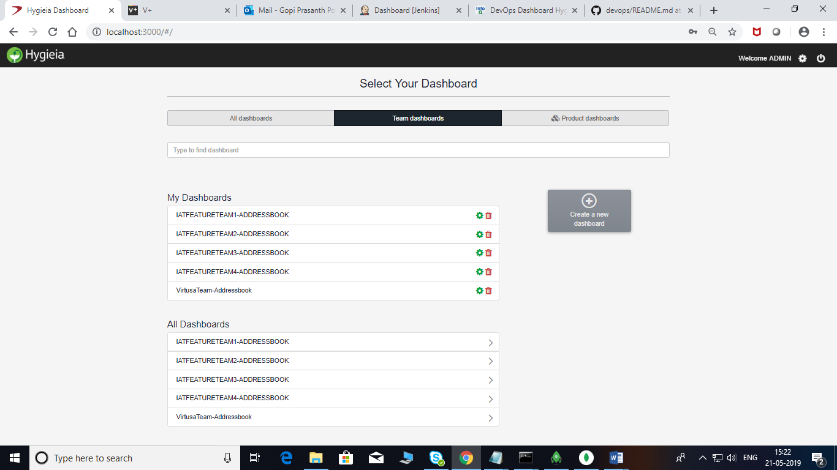

**Configuring Team Dashboard:**

**Feature Widget:**

* Select Agile Tool Type ex: Jira,versionone etc.
* Select Jira Project Name.
* Select The Board Name (if the Collector is in Board Mode) from Dropdown
* Select Estimates,Sprint Type,Features(Epics,issues) and save

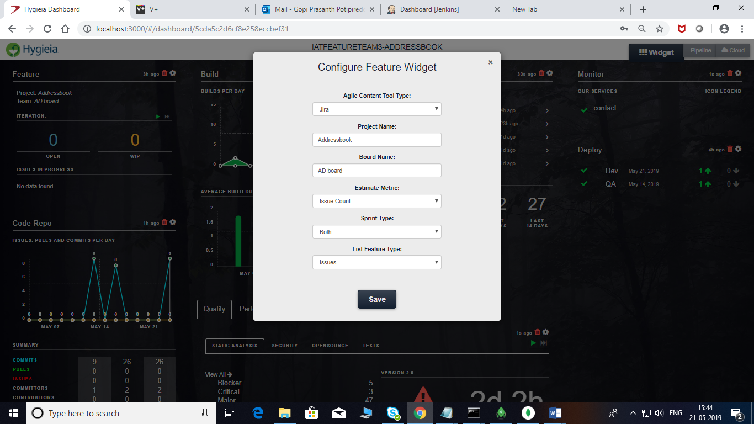

* **The Jira collector Collects the Details from Jira and the Widget looks like below.**

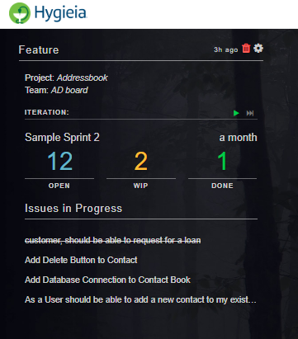

**Build Widget:**

* Click on Configure Widget
* Selects the Build Jobs from Drop Down and Save

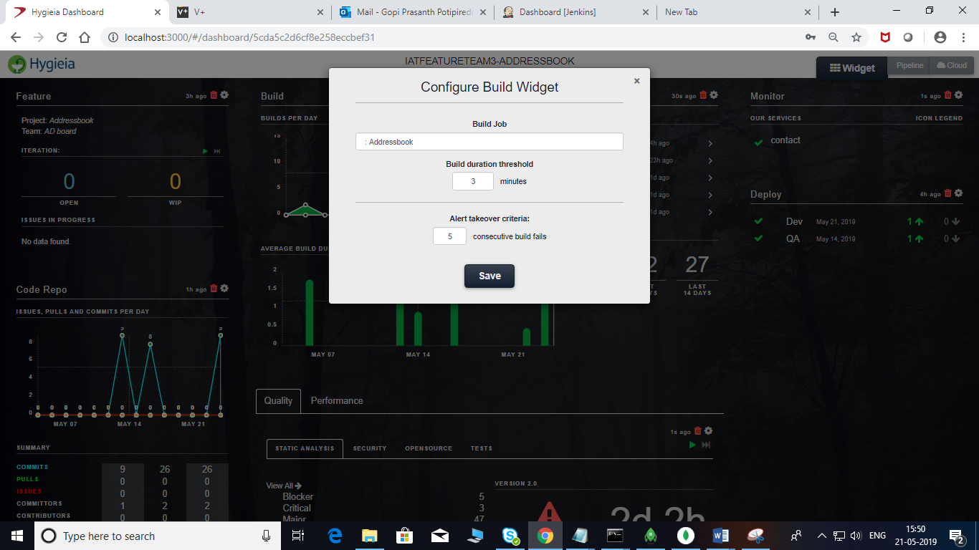

**After the Jenkins Collector Collects the Build info The Widget looks like below**

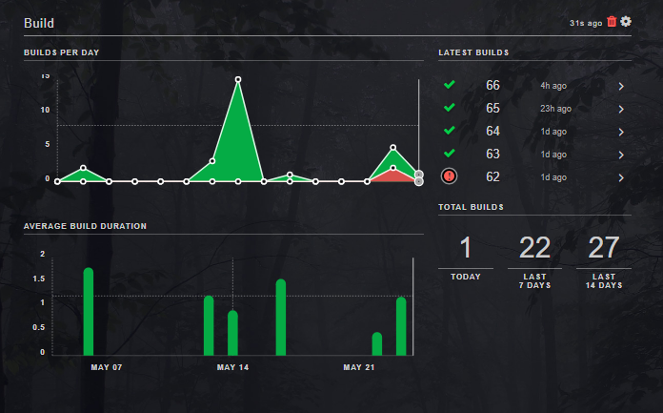

**Code Repo Widget:**

* Click on Configure Widget
* Select Repo Type (Gitlab,Github etc)
* Enter the repo url and Branch
* The username,password or Personal Access Token is optional for Public repos

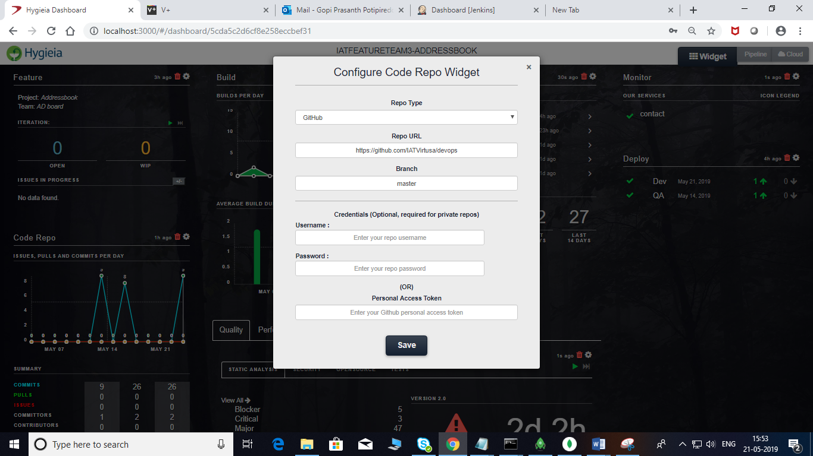

**After Collector Collects Code repo information the widget looks like below**

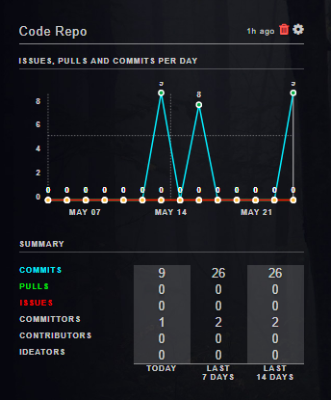

**Code Quality Widget:**

* Click on Configure Widget
* Select The Code Quality Projects from Dropdown
* Select Security Scan and Open Source Scan Jobs if any
* Add Different Functional Tests by Clicking on + Button

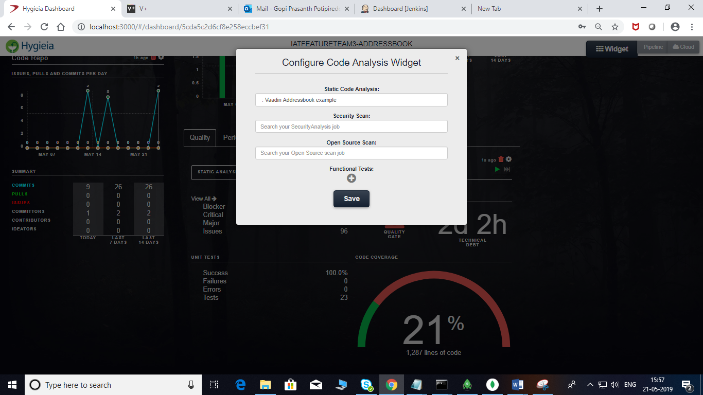

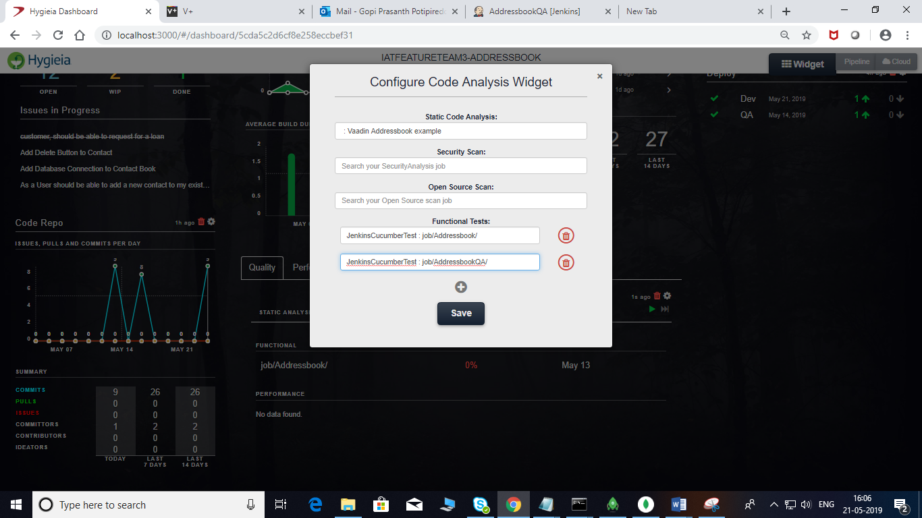

**After Collector Collects Code Quality Info,Other Jobs Info and Tests The Widget Becomes below**

**Quality:**

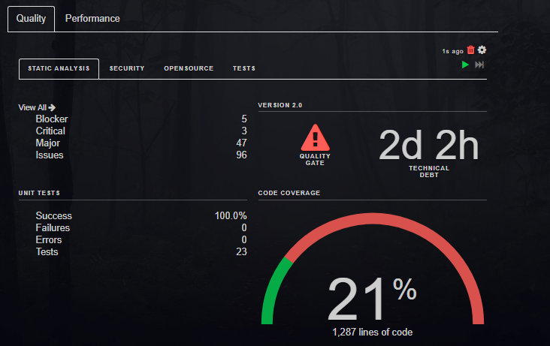

**TESTS:**

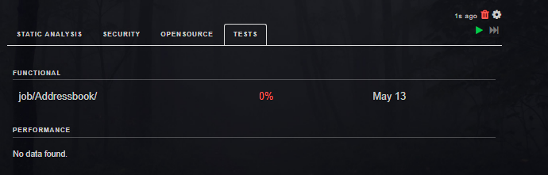

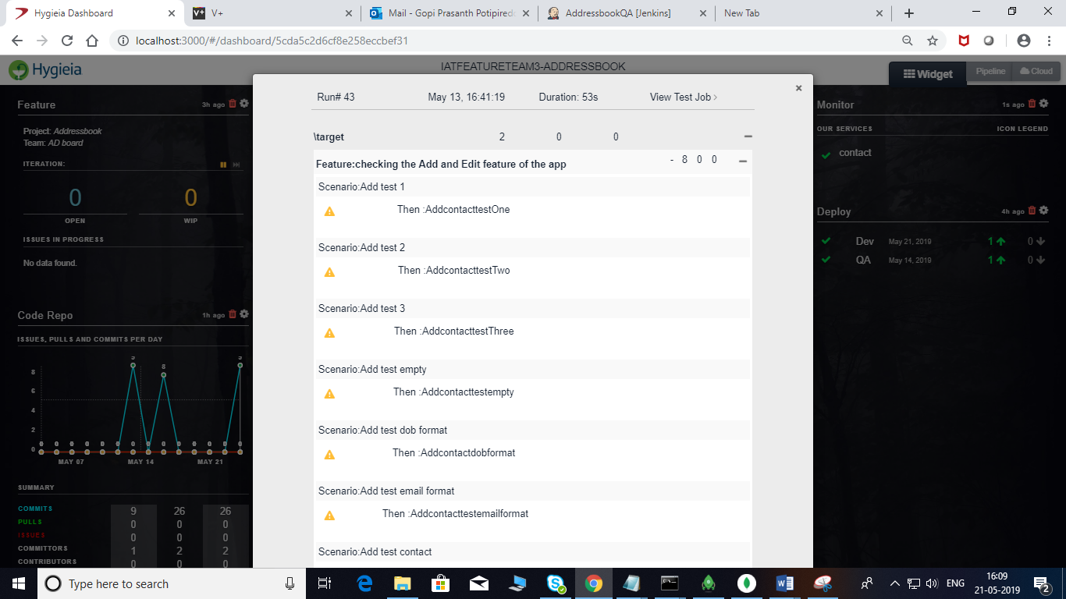

**Monitoring Widget:**

* Click on Configure Widget
* Click on Add Service
* Enter Service Name and Service URL and Save

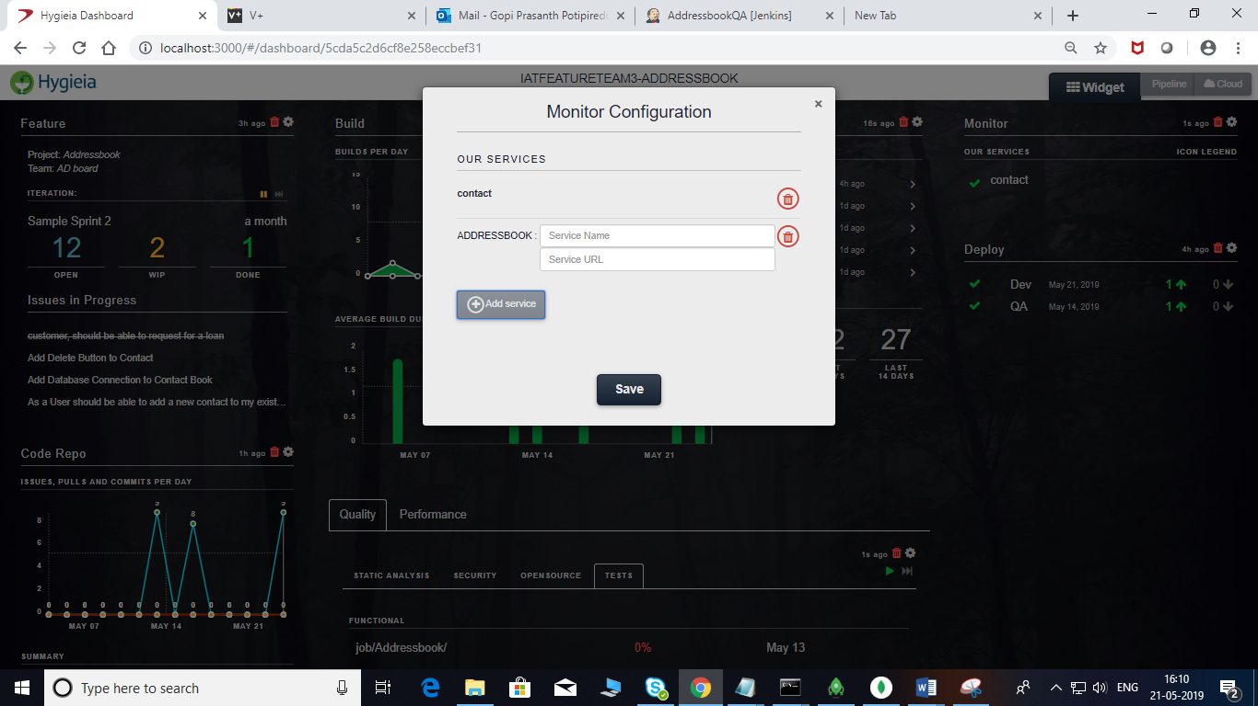

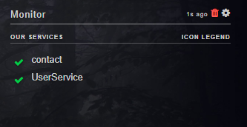

**Deploy Widget:**

* Click on Configure Widget
* Select the Deployment Job from Drop Down list and Save

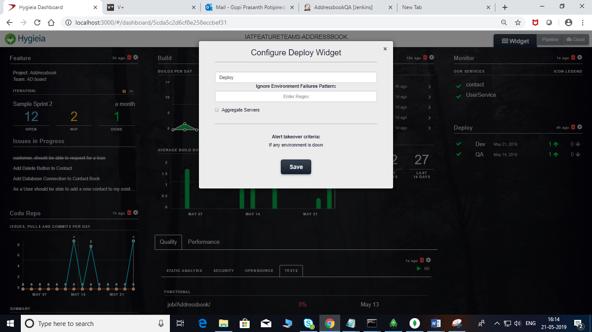

**The widget After Deployment Details looks like below**

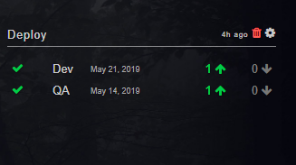

**PIPELINE VIEW CONFIGURATION :**

* Click on Pipeline Tab in the right Upper Corner Of the Dashboard
* Click on Configure
* Select Environments in the Drop Down which are coming from Deployment Widget
* Give Appropriate Name to each Environment
* Click on radio button left to the environment for Production Environment.

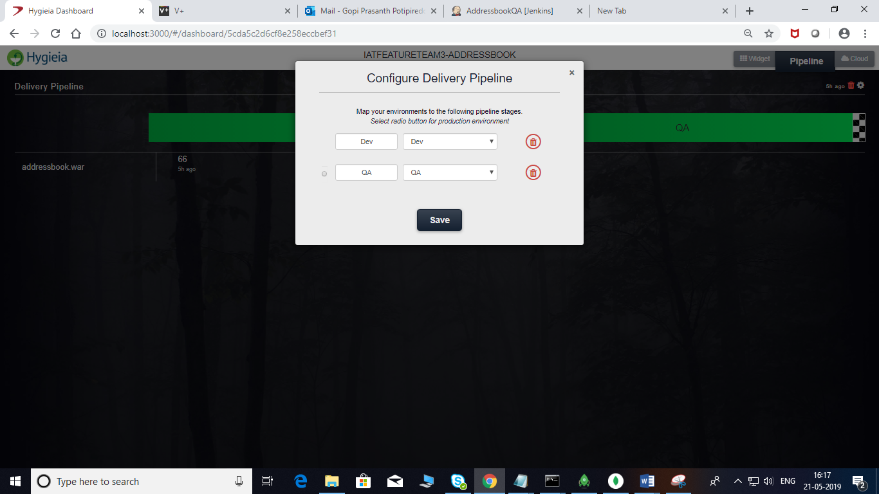

* The Pipe line looks like below

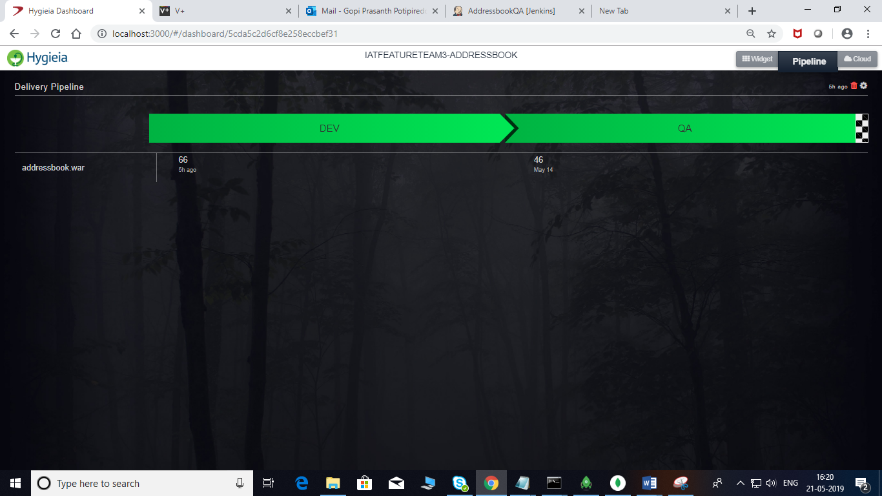

**PRODUCT DASHBOARD CONFIGURATION:**

* Click on Add team
* Select one team from Drop Down those are coming from Team Dashboards
* Give an Optional Custom Name to reflect on Product Dashboard

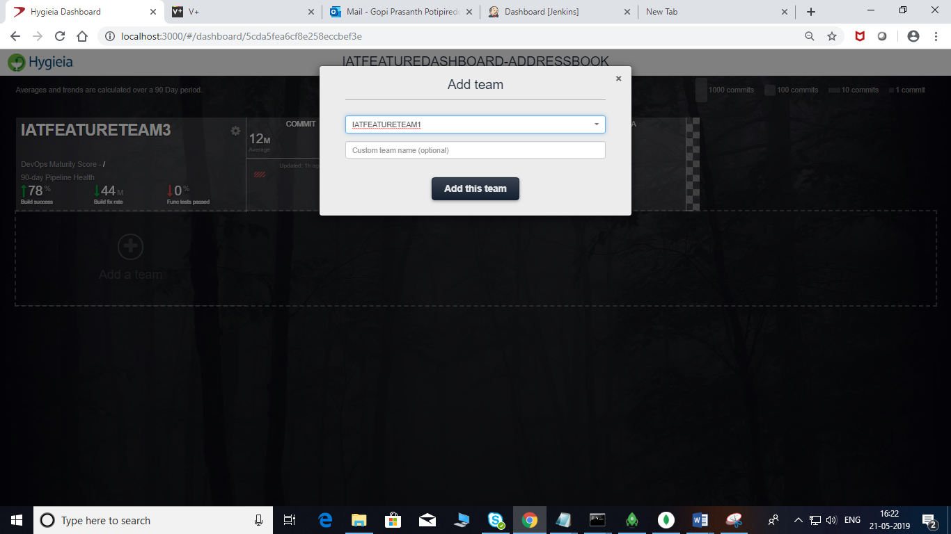

* The Product View looks like below

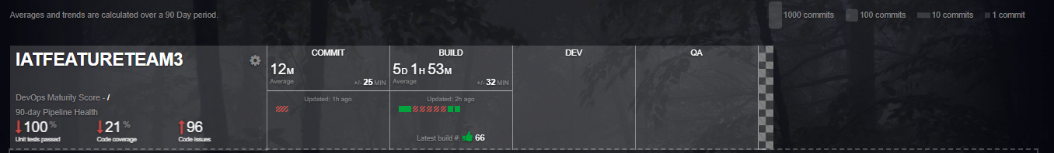

* The 90 day pipeline health view

